IBM Data Science Capstone Project
Problem Definition and Data

Problem Description:
For this project I have chosen to investigate the districts in Stuttgart to find out where there are good places to place an open air restaurant.

Background:
A good place to place a open air restaurant (german Biergarten) might be a location with high throughput of people locals as well as tourists and might be marked as a place with several parks in urban area and som other outdoor takeaway stuff like cafes or icecream shops etc. An other option could be also that there are several metro stations nearby.

Target Audience
The Target audience are businessman evaluating opening a new restaurant as well as real estate agents and investors. Those people care about the value of a specific location for opening an open air restaurant. Depending on their focus it could be expected revenue of a beergarden or the amount of value an object has for getting a fair amount of rent.

Data:
1. Wikipedia for getting the Districts of Stuttgart
2. Geocoder to get Locationdata of Districts
3. Foursquare API to get venues in that area

1. Wikipedia
https://de.wikipedia.org/wiki/Liste_der_Stadtbezirke_und_Stadtteile_von_Stuttgart
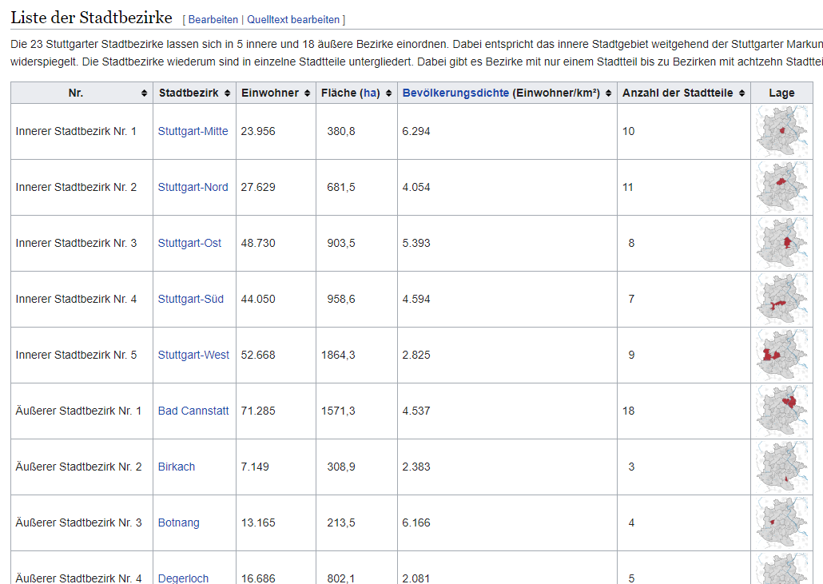

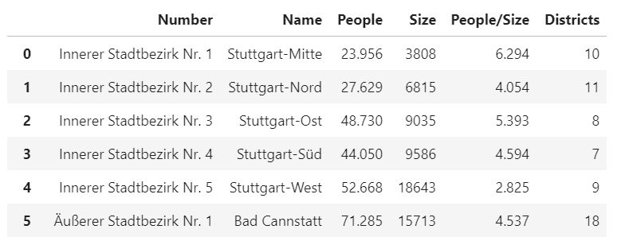

The relevant feature in the list of districts is the name this data is used for getting all districts of Stuttgart
2. Geocoder
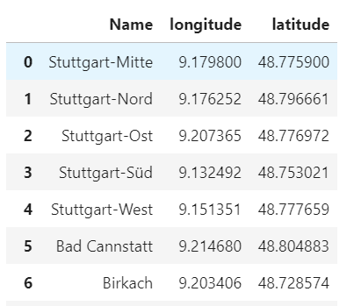

The relevant Feature here is the location (longitude and latitude) for each prior extracted district to have a center point per district for fetching afterwards venue data.
3. Foursquare API
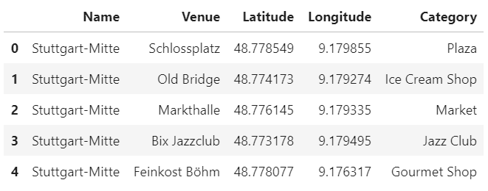

From the Foursquare API there are many possible features in that analyis I extract the Category of the venues which are in a specific radius of a distrcit center so relevant features are name of district and category.

Idea to solve the Problem:

Fetching the top venues per district and then clustering the distrincts by applying K-Means algorithm. Then interpret the clusters and draw a conclusion which cluster might fit best

